CENTRE FOR GRADUATE STUDIES
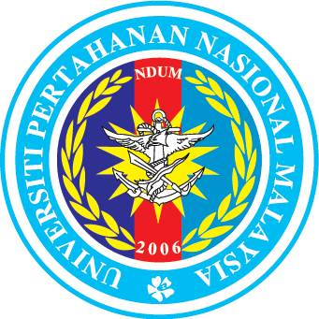Duty, Honour, Integrity
PPS – 07-A
NATIONAL DEFENCE UNIVERSITY MALAYSIA

THESIS SUBMISSION FOR VIVA

Please submit six (6) copies of soft bound thesis and one (1) CD.
Students must ensure that the thesis have been submitted for proof reading and please provide proof/receipt of proof reading from Language Centre UPNM.

Please enclose Turnitin report of the thesis.

SECTION A: TO BE COMPLETED BY STUDENT

- Full Name: ________________________________________________________________
- Matric No.: __________________ 3. Programme: ________________________________
4. Month and Year of Entry into the programme: ________________________________________
5. Field of study: _________________________________________________________________
6. Faculty: _________________________________________________________________
7. Proposed Thesis Title: ______________________________________________________________________________
______________________________________________________________________________
______________________________________________________________________________

____________________________________ _________________________
Student’s Signature Date

SECTION B: FOR FACULTY USE

- Verification by the Chairperson of the Supervision Committee.

We confirmed that we have read and approved of ________________________________________
(student’s name) submitting his/her thesis for viva.

____________________________________ _________________________
Signature and Official Stamp Date
Chairperson of the Supervision Committee

____________________________________ _________________________
Signature and Official Stamp Date
Co-Supervisor

____________________________________ _________________________
Signature and Official Stamp Date
Co-Supervisor

SECTION C: FOR CENTRE FOR GRADUATE STUDIES USE

Please tick(√) in the box provided:
Six (6) copies of soft bound thesis

One (1) CD

Proof/Receipt of proof reading from Language Centre UPNM

Turnitin report

Received by:
Signature: _______________________________________
Officer’s Name: _______________________________________
Date: _______________________________________
Revised Jan 2019

