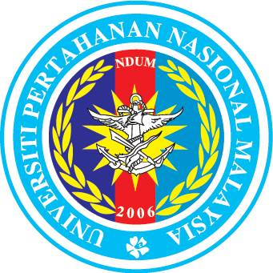Duty, Honour, Integrity
PPS - 06
NATIONAL DEFENCE UNIVERSITY OF MALAYSIA
THESIS SUBMISSION NOTICE

- This form needs to be submitted not later than three (3) months before thesis submission date for examination.
- Please enclose abstract of the thesis.
- Please make sure Part A and Part B is completed before submit to PPS.

SECTION A: TO BE COMPLETED BY STUDENT

- Full Name: _________________________________________________________________
- Matric No.: ____________________ 3. Number of Registered Semesters:
- Programme: _______________________________________________________________
5. Field of Study: _______________________________________________________________
6. Faculty: _______________________________________________________________
7. Thesis Title (use CAPITAL LETTERS): _____________________________________________
______________________________________________________________________________
______________________________________________________________________________
______________________________________________________________________________
- This is to inform you that I will submit my thesis for examination three (3) months within three (3) month after the date of this notice.
- I understand that if I fail to submit my thesis within three (3) months, this notice of submission is considered void and I will submit a new notice of submission.
- I understand that I am required to pay all prescribed fees before submitting the thesis.

____________________________ _________________________
Student’s Signature Date

SECTION B: SUPERVISOR VERIFICATION

I hereby confirm that ____________________________________________ (student’s name) ________________________ (matric No.) has agreed to submit his/her thesis three (3) months from the date ________________________. In this regard, I hereby *endorse/do not endorse the candidate’s intention to submit the draft copies of thesis for examination three (3) months after the date of this notice.

_______________________________________ _________________________
Signature and Official Stamp of Main Supervisor Date
SECTION C: FACULTY RECOMMENDATION

Recommendation by the Faculty Graduate Studies Committee:
The Faculty Graduate Studies Committee has recommended the appointment of the following External and Internal Examiners:-

(a) Candidates for the INTERNAL EXAMINER (please list according to priority)
Name | Expertise

(1)

(2)

(b) Candidates for the EXTERNAL EXAMINER (please list according to priority)
Name | Expertise

(1)

(2)

(3)

____________________________________ _________________________
Signature and Official Stamp Date
Important Notice:-
- For Master candidates, one External Examiner and one Internal Examiner shall be appointed. The faculty must recommend at least two (2) candidates each for both the External and Internal Examiner.
- For PhD candidates, two External Examiners and one Internal Examiner shall be appointed. The faculty must recommend at least two (2) candidates for the Internal Examiner and three (3) candidates for the External Examiner.
- Please enclose CV of the External Examiner.
Dean

SECTION D: VERIFICATION BY THE CENTRE FOR GRADUATE STUDIES

Received by:

Signature: _______________________________________

Officer’s Name: _______________________________________

Date: _______________________________________

