


GRADUATE RESEARCH ASSISTANCE (GRA)
PROGRESS REPORT

(TO BE SUBMITTED EVERY 3 MONTHS OR FOR GRA EXTENSION)

PLEASE TICK (/) WHICHEVER APPLICABLE

NAME OF SUPERVISOR

NAME OF GRA

PROJECT TITLE

DATE OF APPOINTMENT

DATE OF REPORT

FACULTY/CENTRE

:

:

:

:

:

:

SECTION A

1. List of publications in citations-indexed journal (ISI Web of Science/Scopus).
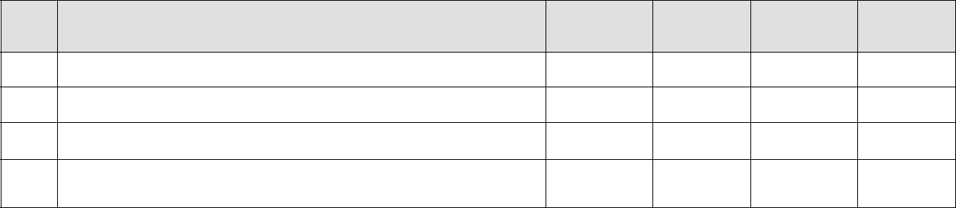

No. | Publications | ISI WoS | Scopus | Impact | Year
No. | (authors, title, journal, year, volume, pages) | ISI WoS | Scopus | Factor | Year

2. List of publications in non citations-indexed journal.

 | No. |  |  | Publications |  |  | Year
 | No. |  |  | (authors, title, journal, year, volume, pages) |  |  | Year

1

3. List of publications submitted / under review

 | No. |  |  | Publications |  |  | ISI WoS
 | No. |  |  | (authors, title, journal, status) |  |  | ISI WoS |  |  | Scopus |  |  | Others

4. Other publications (e.g. books, chapter in books, proceedings, etc.)

 | No. |  |  | Publications |  |  | Year
 | No. |  |  | (authors, title, proceeding/conference name, year, volume, pages) |  |  | Year

5. Grant Applied (e.g. FRGS,PRGS,GPJP, etc.)

No. | Grant Title | Status

6. Other research outputs (e.g. products, patent, networking, etc.)

No. | Title | Year

Note:

Please attach a copy of all publications/documents listed above.

Signature: |  | Date:
 | (GRA)
Name:

2
Supervisor’s comment on Progress Report:

_________________________________________________________________________

_________________________________________________________________________

_________________________________________________________________________

_________________________________________________________________________

_________________________________________________________________________

_________________________________________________________________________

_________________________________________________________________________

_________________________________________________________________________

Graduate Research Assistance’s overall rating for the following:

(a) | Diligence |  | (b) | Attendance
(c) | Interest |  | (d) | Work Quality and Efficiency
(e) | English Proficiency:
(i) | Written |  | (ii) | Oral
(f) | Ability to work |  | (g) | Overall Performance
 | Independently

A Excellent | B Very Good | C Good | D Satisfactory
E Average | F Unsatisfactory |  | G Poor

Signature: Date:

(Supervisor)

Name:

3

